Init Beaglebone connection 1
Init the CAM 1
Get Images 1
Convert RGB to Intensity 2
Convert to BW 3
Remove border blobs 4
Calulate Area 5
Get color matrix of foreground 6
Calc CIE La*b* 7
Calc RI 8
Left behind particles 9

Init Beaglebone connection
tic;
clear;
bbb = beaglebone_black('192.168.178.20', 'root', 'open');
system(bbb, './pwm_vision_matlab');
formatSpec = 'Setting up de Beaglebone %d [sec].';
str = sprintf(formatSpec,toc);
disp(str);
Setting up de Beaglebone 4.106146e+00 [sec].

Init the CAM
tic;
cam = videoinput('winvideo', 1, 'MJPG_2048x1536');
cam.FramesPerTrigger = 20;
border = 0;
cam.ROIPosition = [ border border 2048-border 1536-border ];
src = getselectedsource(cam);
src.BacklightCompensation = 'off';
src.Sharpness = 5;
src.Contrast = 40;
formatSpec = 'Setting up de cam %d [sec].';
str = sprintf(formatSpec,toc);
disp(str);
Setting up de cam 2.263421e+00 [sec].

Get Images
tic;
system(bbb, 'echo 1 > /sys/class/gpio/gpio51/value && echo 1 > /sys/class/gpio/gpio50/value && echo 1 > /sys/class/gpio/gpio60/value');
start(cam)
M = getdata(cam);
I = M(:,:,:,20);
system(bbb, 'echo 0 > /sys/class/gpio/gpio51/value && echo 0 > /sys/class/gpio/gpio50/value && echo 0 > /sys/class/gpio/gpio60/value');
imshow(I)
formatSpec = 'Getting a image %d [sec].';
str = sprintf(formatSpec,toc);
disp(str);
Warning: Image is too big to fit on screen; displaying at 50%
Getting a image 9.155018e+00 [sec].
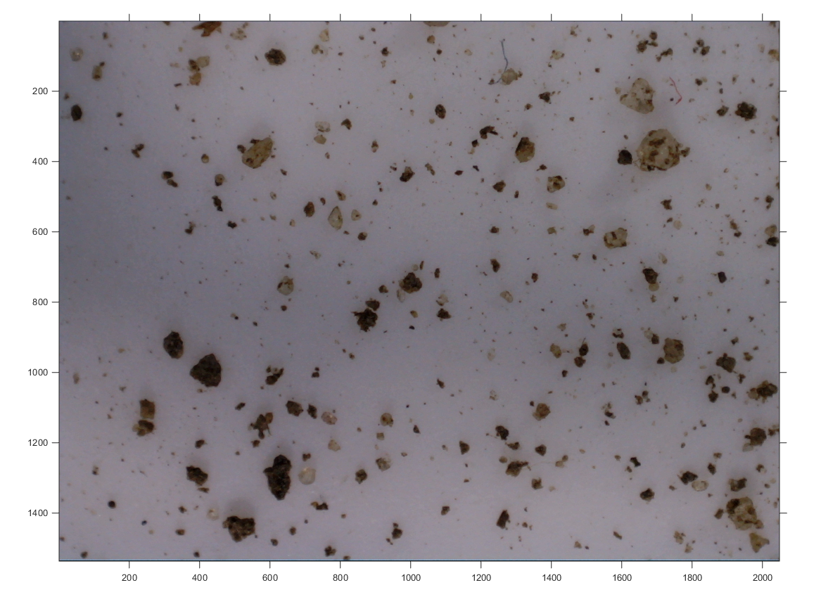

Convert RGB to Intensity
tic;
hcsc = vision.ColorSpaceConverter('Conversion', 'RGB to intensity');
Int = step(hcsc, I);
imshow(Int)
formatSpec = 'Convert RGB to Intensity %d [sec].';
str = sprintf(formatSpec,toc);
disp(str);
Warning: Image is too big to fit on screen; displaying at 50%
Convert RGB to Intensity 1.961357e-01 [sec].
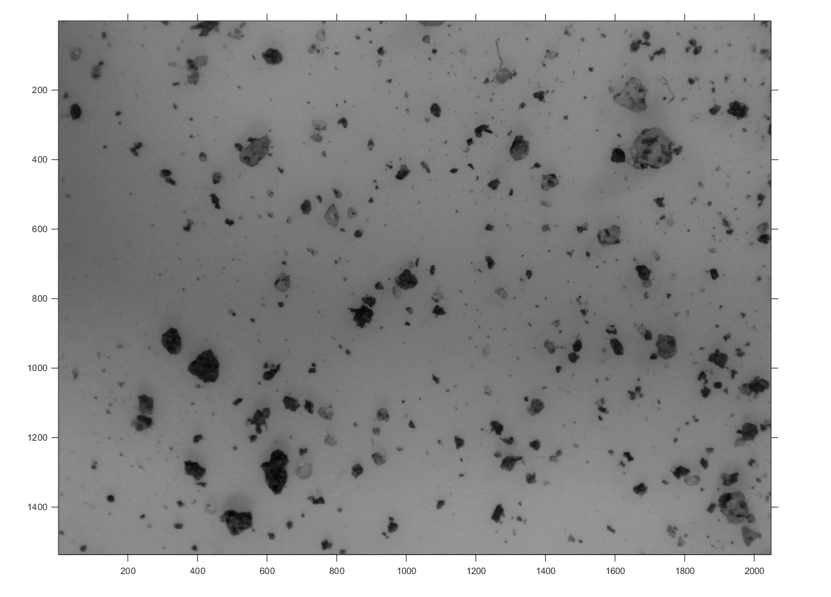

Convert to BW
tic;
BW = GetLabeledImage(I);
imshow(BW)
formatSpec = 'Convert to BW %d [sec].';
str = sprintf(formatSpec,toc);
disp(str);
Warning: Image is too big to fit on screen; displaying at 50%
Convert to BW 1.968725e+01 [sec].
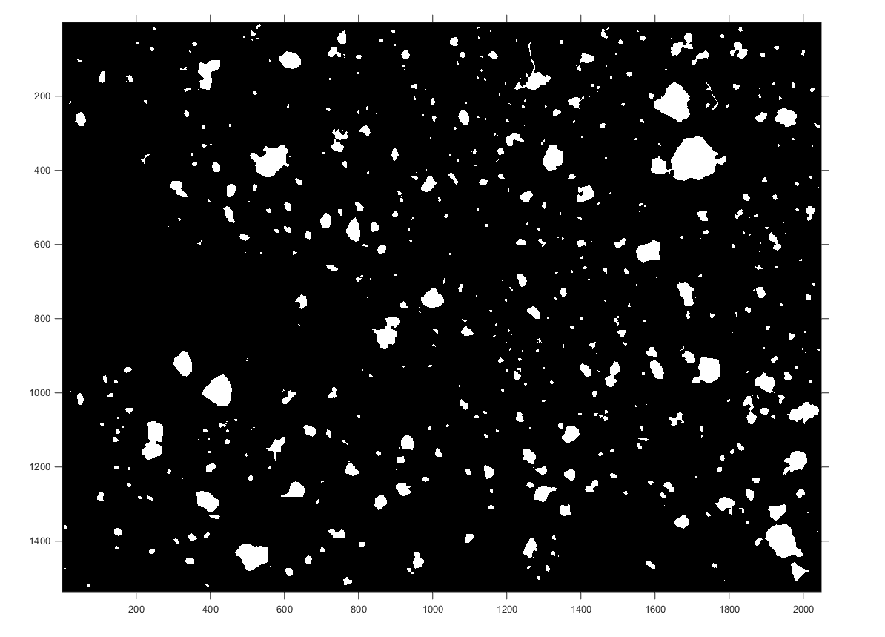

Remove border blobs
tic;
BWl = RemoveBorderBlobs(BW);
imshow(BWl)
formatSpec = 'Remove border blobs %d [sec].';
str = sprintf(formatSpec,toc);
disp(str);
Warning: Image is too big to fit on screen; displaying at 50%
Remove border blobs 1.425609e-01 [sec].

Calulate Area
tic;
area = PSD(BWl);
figure; hist(area);
formatSpec = 'Calulate Area %d [sec].';
str = sprintf(formatSpec,toc);
disp(str);
Calulate Area 9.614259e-02 [sec].
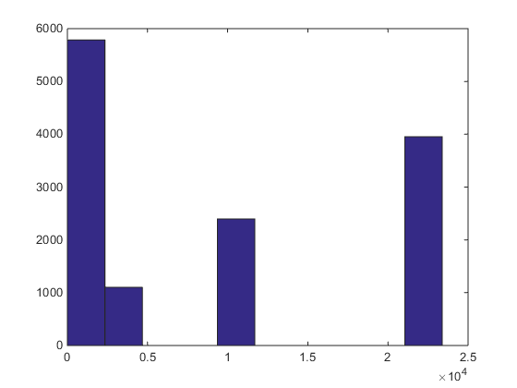

Get color matrix of foreground
tic;
Ic = RemoveBackgroundVectorImage(BW, I);
imshow(Ic);
formatSpec = 'Get Color Matrix %d [sec].';
str = sprintf(formatSpec,toc);
disp(str);
Warning: Image is too big to fit on screen; displaying at 50%
Get Color Matrix 2.739707e-01 [sec].
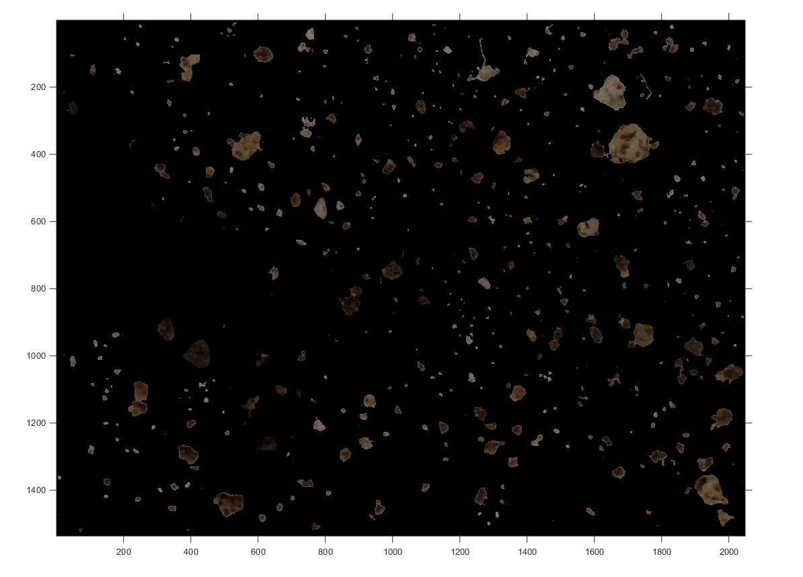

Calc CIE La*b*
tic;
dis = CIELabSoilColorDistribution(BW, I);
figure; scatterhist(dis(:,1),dis(:,2));
formatSpec = 'Calc CIE La*b* alternative 2 %d [sec].';
str = sprintf(formatSpec,toc);
disp(str);
Calc CIE La*b* alternative 2 1.463346e+00 [sec].
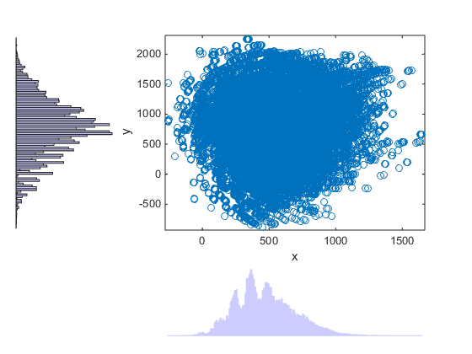

Calc RI
tic;
RI = RISoilColorDistribution(BW, I);
figure; hist(RI);
formatSpec = 'Calc RI %d [sec].';
str = sprintf(formatSpec,toc);
disp(str);
Calc RI 2.119925e+00 [sec].
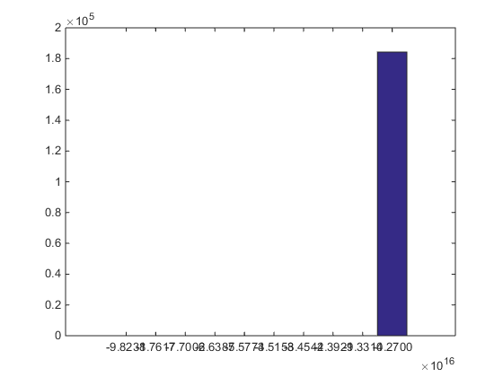

Left behind particles
Inot = RemoveBackgroundVectorImage(~BW, I);
imshow(Inot);
Warning: Image is too big to fit on screen; displaying at 50%
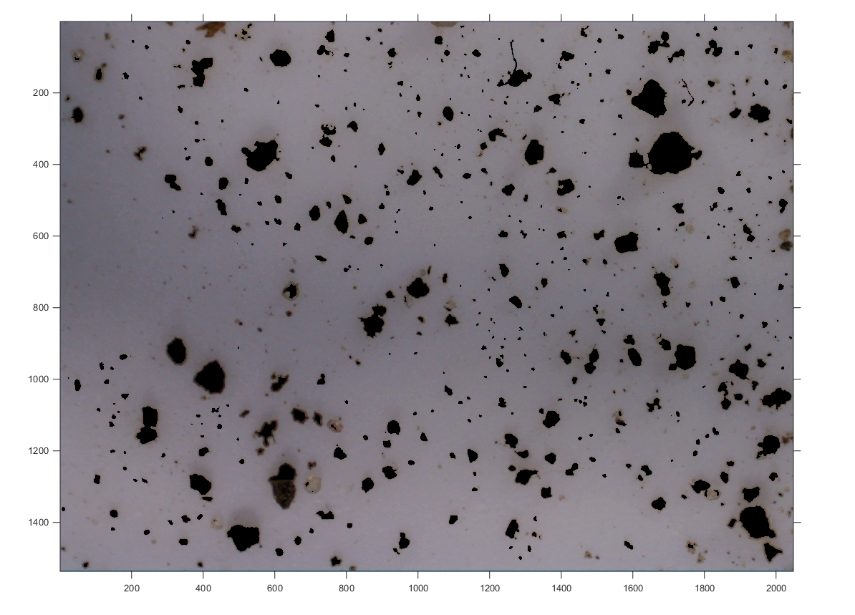
Published with MATLAB® R2014b

